**RECOMMENDER SYSTEMS**

CS697 – Independent Study – ***Dr. Yaohang Li***

**Contents:**

1. **Introduction**
2. **Evaluation of Recommendation Systems**
3. **Framework - Recommender Engine**
4. **Content Based Filtering**
5. **Neighborhood based Collaborative Filtering**
6. **INTRODUCTION**

A system that can predict the preference of a set of items for a user and recommend the top items is referred to as the Recommender Systems. One important reason for the need of a recommender system in modern era is that we have so many options to choose from due to the existence of Internet. Sometime before, we used to shop in a physical store, in which the items available are limited. For example, the number of movies that can be placed in a movie store used to depend on the capacity of that store. In contrast, the Internet nowadays allows people to access numerous resources online. Amazon, for example, has an enormous collection of products relating to various domains. Although the amount of available information increased, a new problem arose as people had a hard time selecting the items they want to see. This is where the recommender system pays off.

There are two traditional kinds in recommender system:

1. Content-based filtering.
2. Collaborative filtering.

Content based systems, recommends books to a user by performing Natural Language Processing on the content of each author. On the other hand, Collaborative Filtering, does not require any information about the items or the users themselves as it recommends items based on user’s past behavior.

A recommender system starts with some sort of information about the user so that it can figure out the individual tastes and interest of that user. It can merge the data about this user with the collective behavior of rest of the similar users. So where does this data from this user come from, one way is users are treated as customers through their explicit feedback. For example, asking users to rate a book from 1-5 or a content they like as a thumbs up or a thumbs down. In this way, the system is asking the user if he/she likes it or not. Eventually it builds up the user profile based on this data of user’s interests.

The problem with explicit ratings or feedback is that it requires additional work from the users and most of the users may not end up providing the feedback for the product they used, and data tends to be very sparse. When the data is too sparse, it results in low quality recommendations. User ratings on the other hand may vary with each user, meaning a 4-star review may not mean same to two different users, showing a different standard for every user may be due to cultural or regional differences.

Another way of understanding the user is through implicit behaviors, this may imply about the user who may do anyhow and interpreting them as interests or disinterests. For example, user may click a link indicating the interest towards the page/ad. But clicks often aren't always the reliable source of information. People often click by accident just by lured by the pic/image. Clicks about the actual purchase as they add up to the purchase behavior.

**Top N Recommender Architecture**:

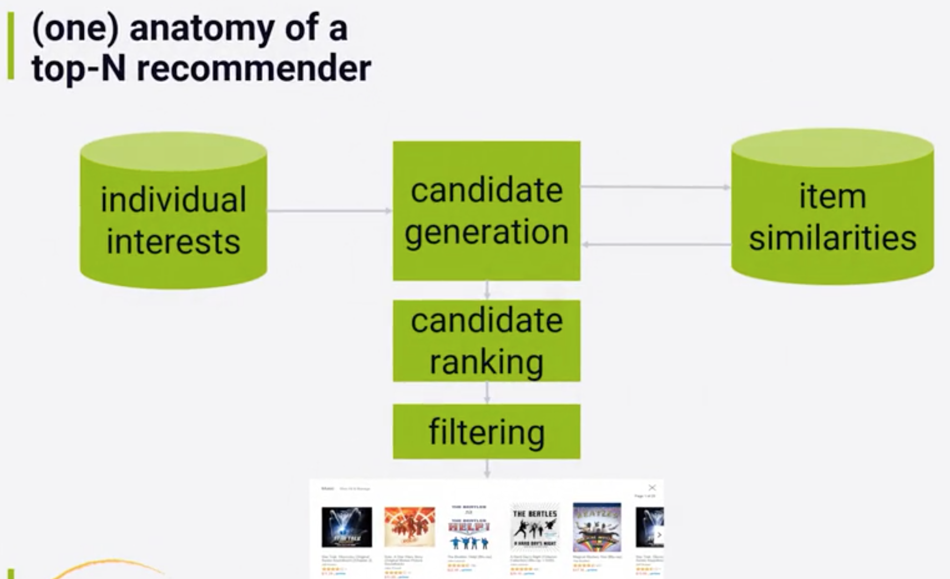

**Individual Interests** refers to a data store of a specific user, which lists the users explicit and implicit rating about the stuff they liked or bought in the past. This could be a no-sql database.

**Candidate generation** phase might take all the user interests and generate the similar items (**item similarity**) based on the aggregate behavior. For example, based on my interest on the move ‘Star Trek’, system might suggest ‘Star Wars’ based on others interest.

**Candidate Ranking** involves sorting the candidates returned through the generation phase based on its scores or calling in a machine learning algorithm to rank the items.

**Filtering** is required to finally recommend the items, so that we do not recommend the items user has already used or reviewed. This might as well include cutting items which are below the threshold of user liking or which are offensive for the user.

**2. EVALUATION – RECOMMENDER SYSTEMS**

Following the fundamental machine learning method for evaluating the performance of the recommendation system. First method consists of dividing the data in to train and test splits and thus training the system on the train data and finally predicting the value by using the test set. Here the data is the collection of all the rating provided by a specific user for all the items and predicting the rating over the test set.

Second method involves performing the k-fold cross validation over the data. This involves dividing the data into random k-fold training sets and predicting the rating over the test set and finally averaging the k-fold results.

These methods will help us evaluate the recommender system but not in recommending new stuff, which users have not seen and may find interesting.

**Accuracy Metrics to test the recommender system:**

1. **Mean Absolute Error (MAE):**

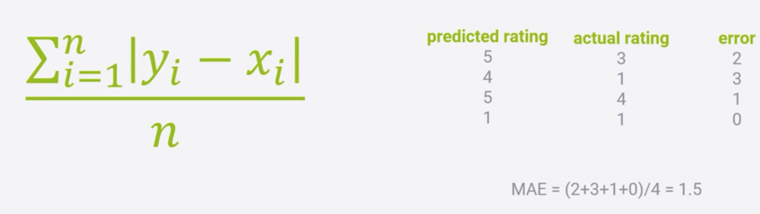

MAE is the sum of the difference between the predicted and actual rating over the total number of ratings. Lowest MAE is better.

1. **Root Mean Square Error (RMSE):**

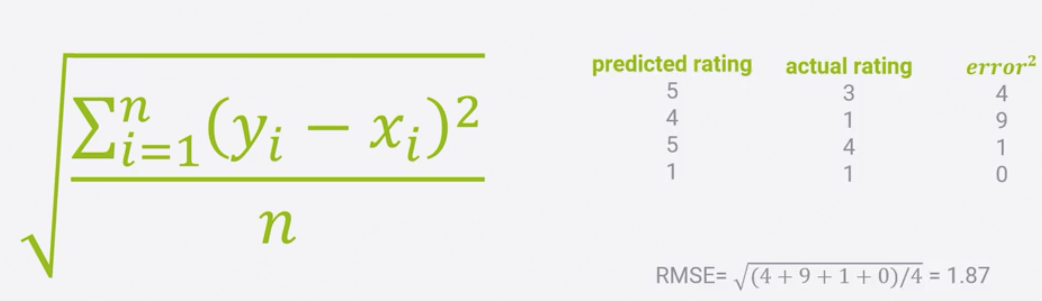

RMSE takes the root over the sum of squared error, which makes it penalize the system if the prediction is way different than the actual and minimizes the value when its less different. Low RMSE is better.

1. **Hit Rate:**

Consider that the system generated the top-n recommendations for the users in the test set and if one of the recommendations among these is rated by the user, then it’s a success. It is considered as a **hit.**  By this we know that the system has managed to recommend something which the user would like.

Adding up the hits by all the users over the number of users is the **hit rate**.

1. **Average Reciprocal Hit Rate (ARHR):**

It is like hit rate, but it accounts for where in the top end list your hits appear. So, we end up in successfully recommending the item in the top slot than in the bottom slot. This is more of user focused metric, as users tend to focus on beginning of list.

Instead of summing the rank of each hit, we sum up the reciprocal rank of each hit.

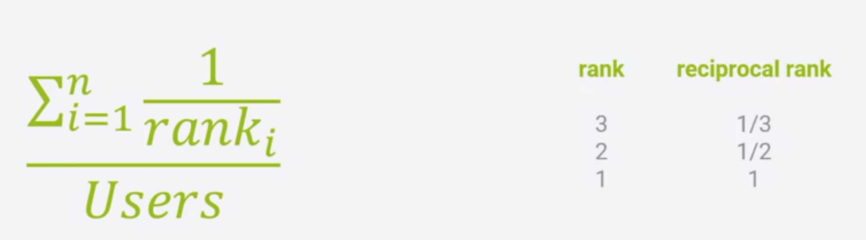

If we successfully predict the recommendation in slot 3, that only counts as 1/3rd. But a hit in slot one of our top end recommendations receives the full weight of 1.

1. **Cumulative hit rank:**

It’s all about ignoring the recommendations if the predicted rating falls below a threshold. The idea is that we shouldn’t get credit for recommending items for the users that we think they actually don’t enjoy.

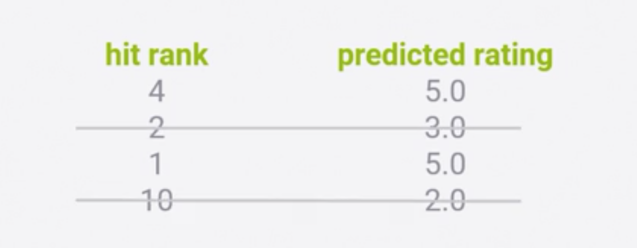

In the above example, if we set a threshold of 3, we need to ignore the second and last items in these test results and our hit rate metric wouldn’t count them at all.

1. **Rating hit rate:**

Another way of looking hit rate is to break it down by predicted rating score. It can be good way to get an idea of the distribution of how good our algorithm thinks the recommended movies are, that get a hit. Ideally you want to recommend movies that they liked and breaking down the distribution gives you some sense of how well we are doing in more detail. This is called **rHR**.

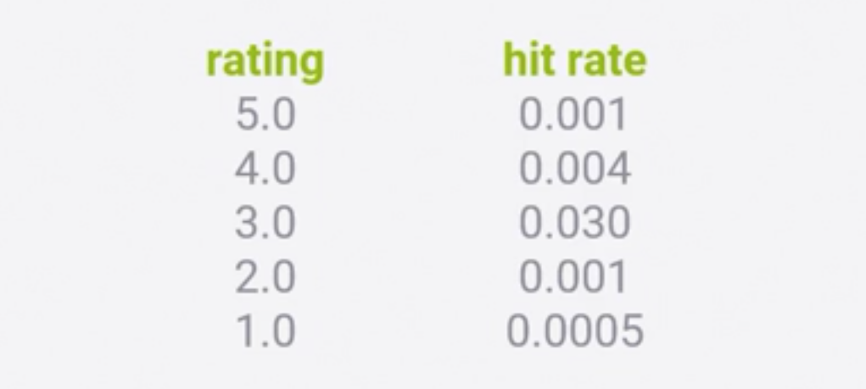

1. **Coverage:**

It’s the percentage of possible recommendations <user, item> that the system provides. Comparing the percentage of recommendation with *MovieLens* dataset with the *IMDB*. The systems recommendation coverage will be less as it will not cover all the movies produced so far.

1. **Diversity:**

It’s how broader your systems recommendation is. Diversity is low, if your system recommends the next series of the book, I'm reading but does not recommend the movies or books you have read. Many recommender systems consider the similarity between the items that they recommend. So, we can use this similarity score, we can measure the diversity. Is S being the similarity, diversity is (1- S).

1. **Novelty:**

It refers to how popular the item is? Recommending a popular item, makes more impression than the less popular ones.

1. **Churn:**

It helps in measuring how sensitive is our system for the new user behavior. If a user rates a new movie and it changes the recommendations for the user, then the churn score is very high.

Recommending the same items may not cause user to like them, instead recommending the new items or randomization may keep user fresh. High churn is also not a good incentive but looking all the metrics together makes more sense.

J. **Responsiveness**:

It is how soon does the change in recommendation appear.

**Which metric system is better?**

It depends on the platform for considering the right metric system.

Measuring all these metrics through training ***MovieLens*** dataset. Randomly setting 25% for testing and remaining 75% for training using SVD algorithm. We are trying to create top-n recommendations for all the users and measure all the metrics.

(Code in /Evaluation/TestMetrics.py)

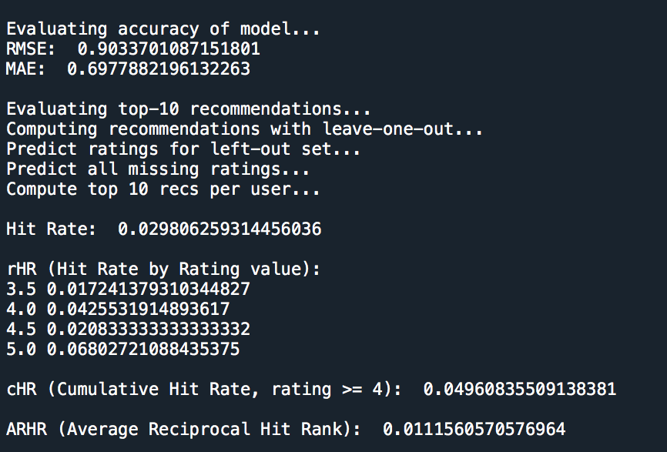

4. **CONTENT BASED FILTERING**

This method deals with recommending items based on the attributes of the items themselves. For example, a movie recommendation based on the genre. The *MovieLens* dataset does not give much attributes for each movie although mentions the genre of the movie. Every movie is given a genre like science fiction, adventure, action, horror, romance., etc. If we know that a given user like science fiction movie, it's reasonable to recommend other science fiction movies to that user. MovieLens also includes the year of the movie to the title of the movie.

Instead of recommending all the science fiction movies to this user, we can narrow it down to the science fiction movies released in that year. In addition, we can aggregate the MovieLens dataset with IMDB to get more information such as cast, director., etc.

MovieLens Dataset example:

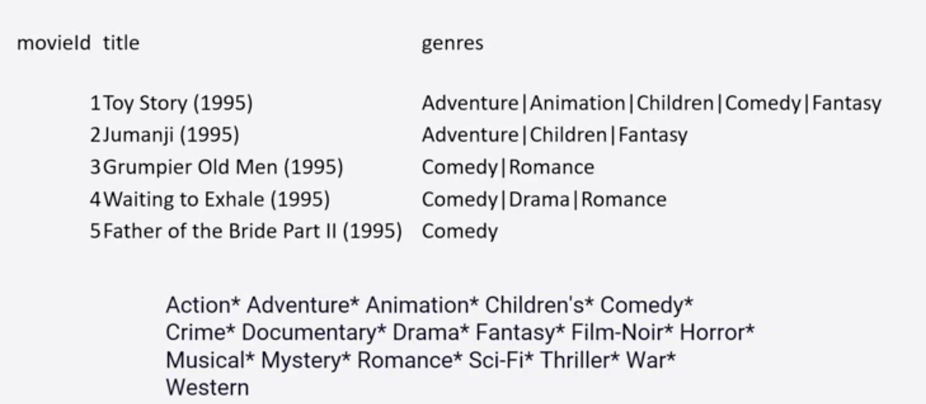

How do we determine the similarity of the movies?

Each movie may possibly have 18 different types of genre. One way is with cosine similarity

Let's plot a 2D graph and label x-axis with the comedy genre and y-axis with adventure, any movie belonging to a genre gets a value 1 or 0 otherwise. If we throw in two movies, for example, ‘Toy Story’ and ‘Grumpy Old Man’. Toy Story (1,1) happens to be an adventure and a comedy movie but Grumpy old Man is purely a comedy movie (0,1). They form an angle of 45 degrees and cosine 45 degrees will be 0.75.

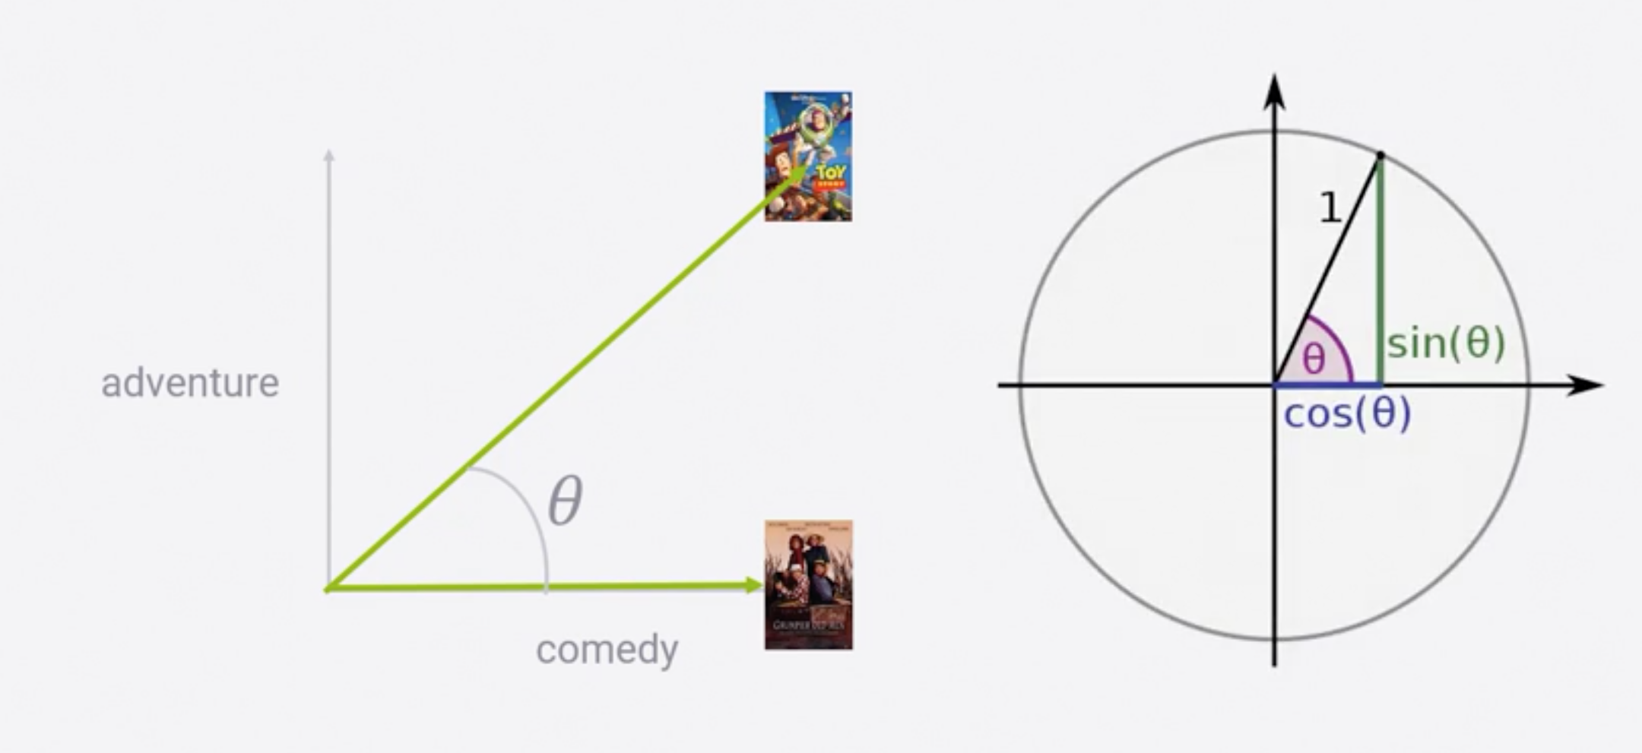

So how about adding another movie *Monty python and the Holy Grail* into the plot. Now this movie belongs to both the adventure and comedy plot. So, a cosine 0, refers to 1, meaning similar movies. Adding ‘Indiana Jones’ being an adventure movie the cosine similarity becomes 1 between it and *Grumpy Old Man.*

Now how do we measure the cosine similarity with every other movie in 18 dimensions?

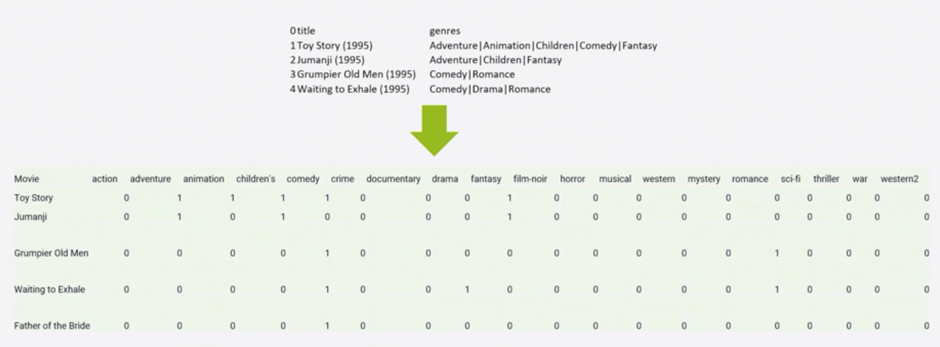

Mathematically it can be computed as below formulae:

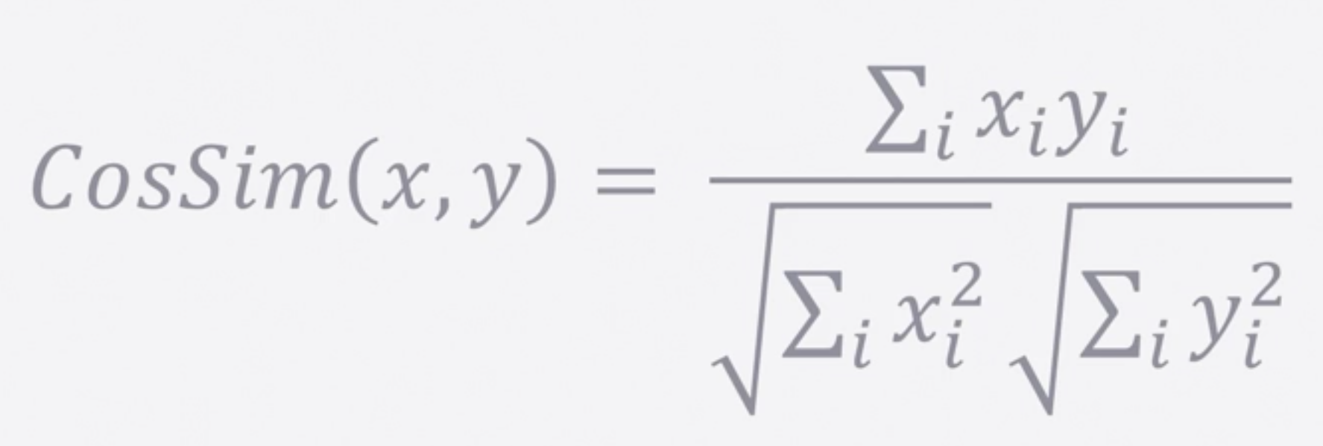

Having obtained the movie similarity, how can we predict the rating for a given user for a given movie. ?

This can be achieved through a k-nearest neighbors. We start by measuring the content-based similarity between everything a given user has rated and a movie we want to predict a rating for. We can define the nearest however we want, in our case, nearest neighbors are the movies with highest content-based similarity between the movie we are trying to predict the rating for.

In our case, top 40 movies whose genre and release dates are close enough for a movie we want to recommend for this user. So, turn these top 40 movies into the actual rating prediction, we can just take the weighted average of their similarity score to the movie we are trying to predict for, weighting them by the rating user gave them.

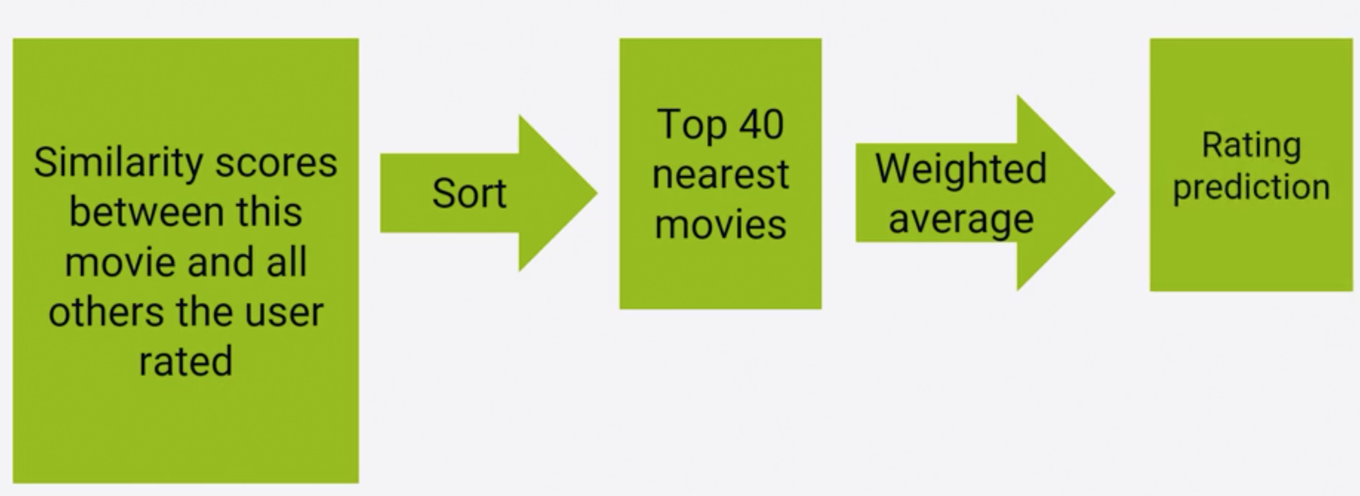

Let's try to predict the movie for a given user based on the genre and movie release year relating to the movies the user liked.

I have selected user no 85 to predict the movie recommendation based on genre and year of release. I’m comparing KNN algorithm with Random algorithm to verify the evaluation metrics and recommendations.

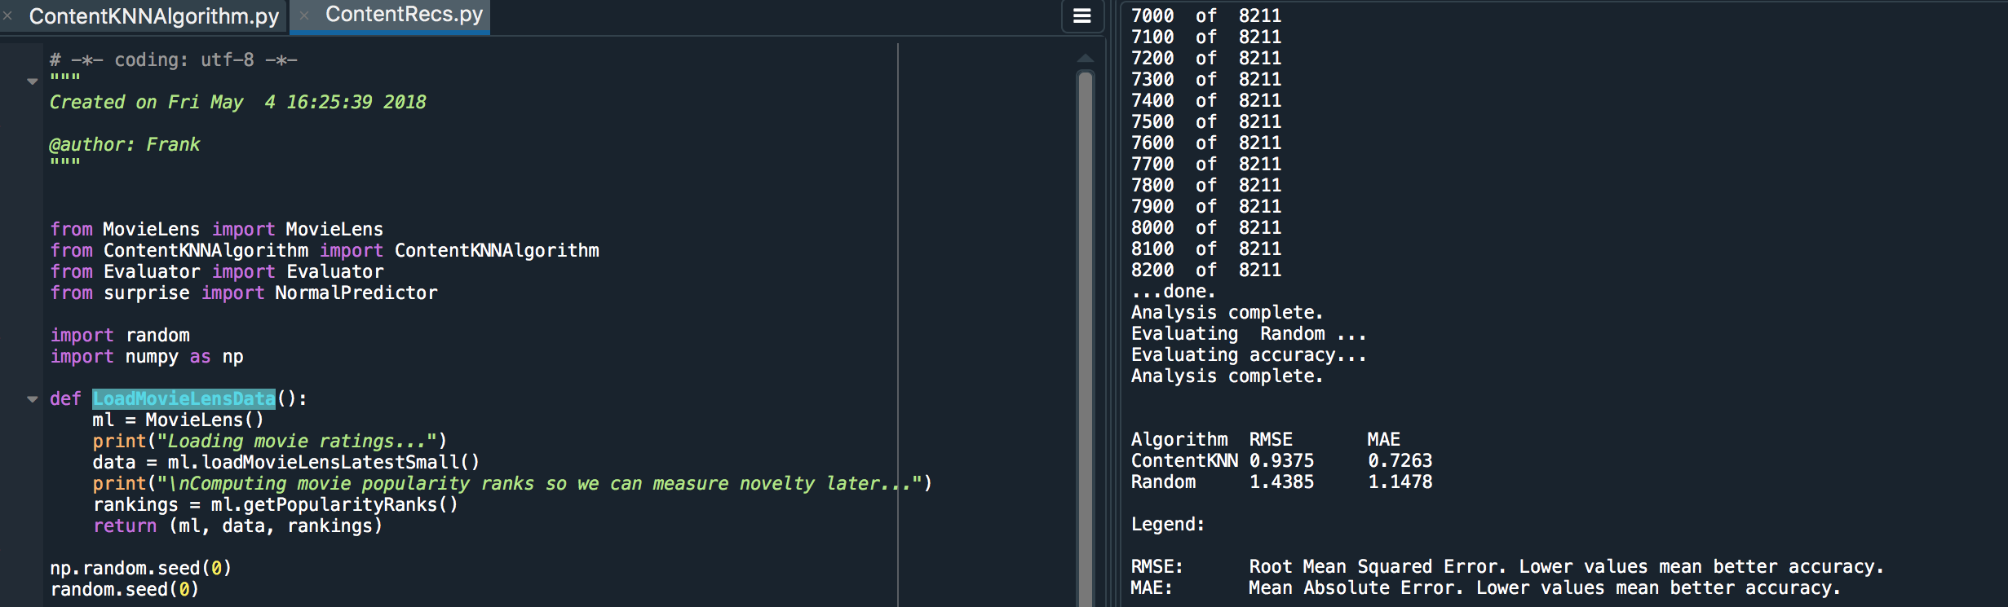

Here we can observe that KNN algorithm has less RMSE and MAE compared to Random algorithm.

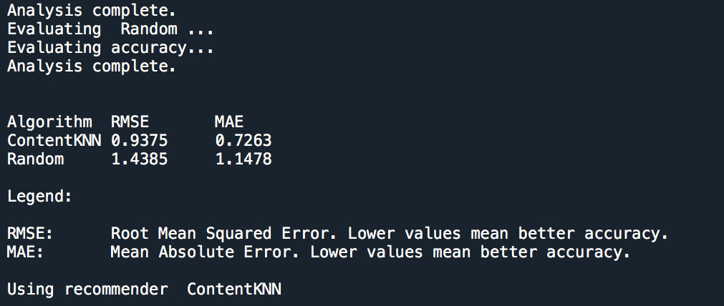

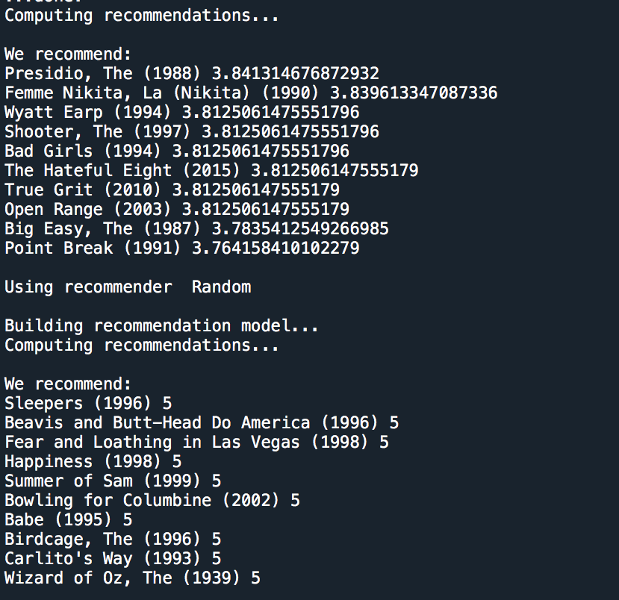

1. **Neighborhood based Collaborative Filtering**

It basically deals with finding other people like me and recommending what they liked, or it might mean finding other things similar to what you like and not seen yet. It's all about recommending stuff based on other people’s collaborative behavior.

Now, how to determine the people like me or things similar to what I like?

It almost in the ways that we applied content-based similarity to find the similar movies, we would apply the same technique to measure the similarity on the behavior data. For example, applying similarity check on *apple,* I recently bought or similarity between people like me.

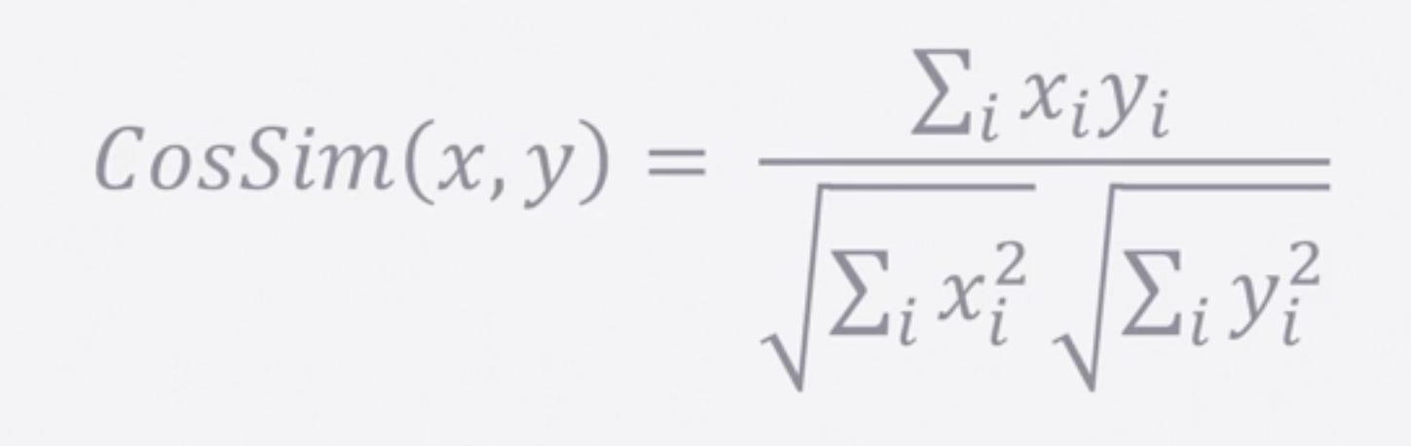

Plotting the similarity between the features of multiple things or people behavior to identify the similarity will be the right method. The dimension of comparison will be whether this user liked this thing or was this thing liked by the user rather than the content attributes.

So, if we apply this idea to the *MovieLens* data, it appears that there will be a lot of sparse data. As nobody as seen all the movies on the dataset.

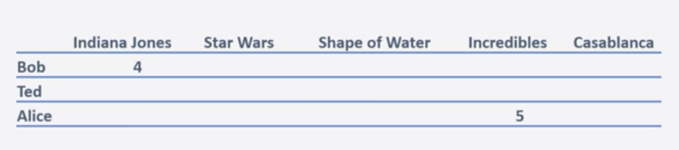

So, on the above example, we can observe that Bob and Alice have rated only one movie while Ted has watched none, also how can we obtain the features. It’s difficult to measure the similarity with the items if we have 100 thousand items with less features. This also introduces computational challenges as storing and handling involves using data structures like *Sparse Arrays.* The quantity and quality of the data is way more important than the algorithm we try to choose to measure similarity.

**Adjusted Similarity**:

This method tries to find the similarity between users based on their ratings. It basically depends on the baseline that users are working on. There could be a difference in what Bob feels a 5-start rating with what Alice thinks of a 5-star rating. This method captures the similarity as the difference between user’s rating for an item and the average rating of this user for all the items.

X-bar refers to average of the user X’s rating and X-I refers to rating for an item (its same for user Y).

**Pearson Similarity:**

Another way of looking at similarity is difference between a user rating for an item and average rating of all the users for that specific item, as defined below:

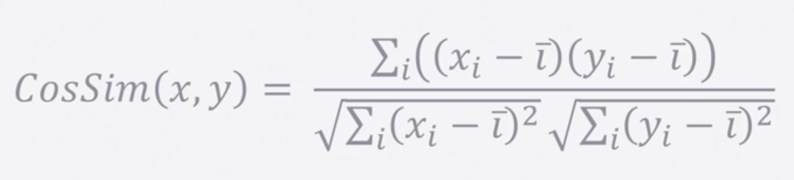

**Mean Squared Difference:**

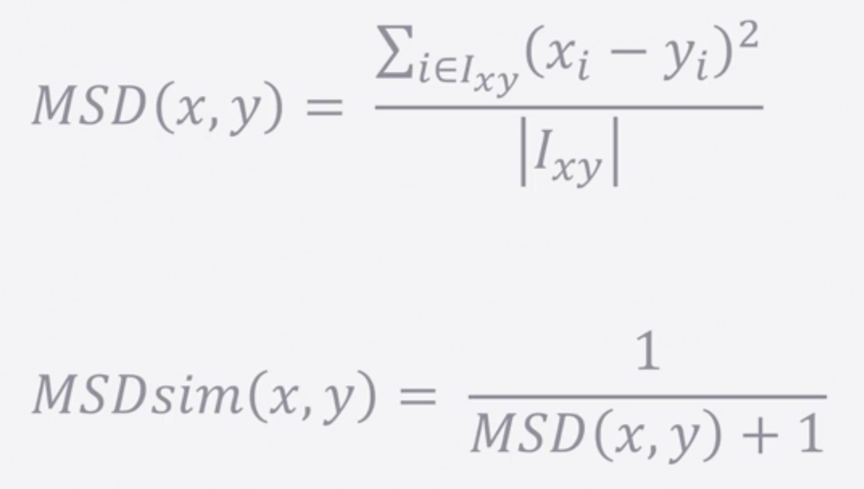

It's about looking at all the items two users have in common in their ratings and compute the mean of the squared differences between how each user rated each item.

Mentioning about the first equation on the top, it’s the summation of the difference between the two users rating on the common items they two rated over the total common items. As we must measure the similarity, we need to flip it and add 1 to the denominator to avoid divide by zero, when their rating is identical.

**User based Collaborative Filtering:**

It begins by finding the users who are similar to me by looking at their behavior. Consider a situation where Alice and Bob both like *Starwars,* but Bob hasn’t seen the *Empire Strikes Back.*

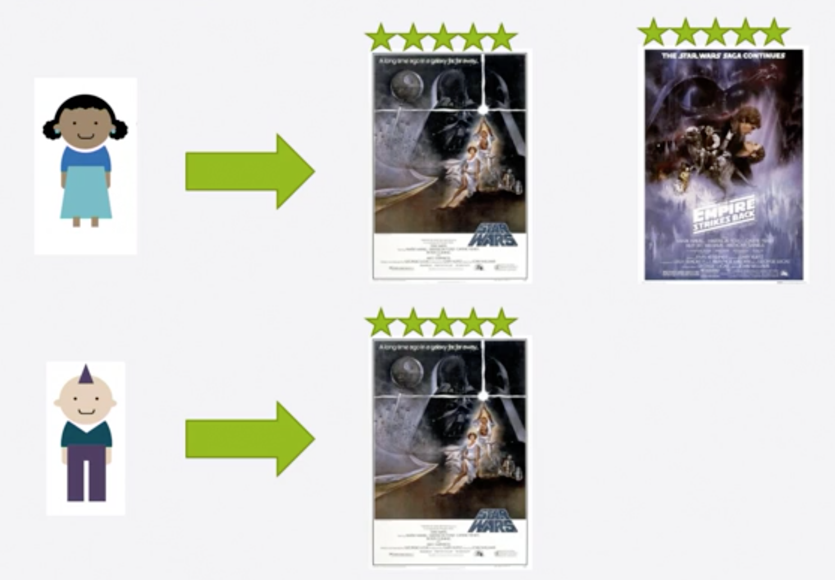

In that case recommending *Empire Strikes back* to Bob will be the right choice.

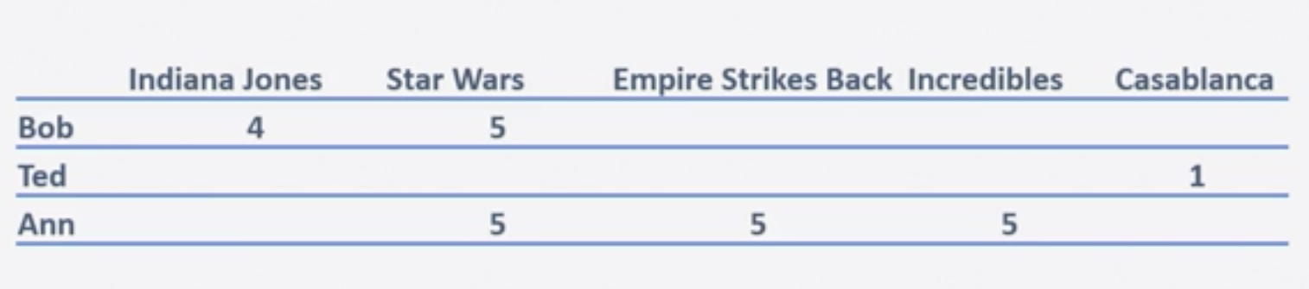

We can see a matrix with users and their rating for the respective movies.

With Cosine similarity, we are computing the similarity over the movies the two users have rated in common. It's easy to pick the most similar user for each user and ignore others. Here we assign a similarity score of 1.0 to Ann with respect to Bob. Now it’s easy to recommend what Ann has watched and remove identical items before recommending Ann’s choices to Bob.

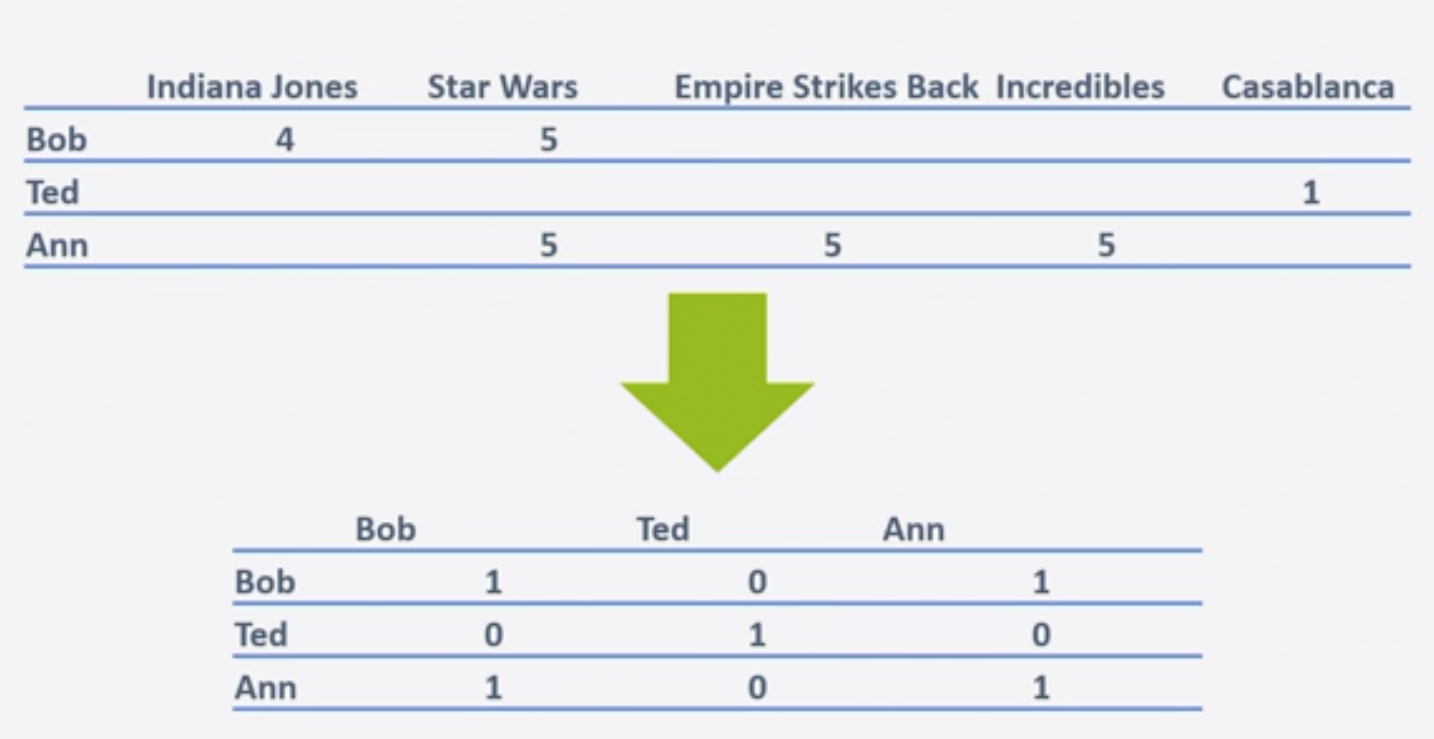

Let's run this on the real time data, which is our MovieLens data by running *SimpleUserCF.py.*

Recommended movies for User 85.

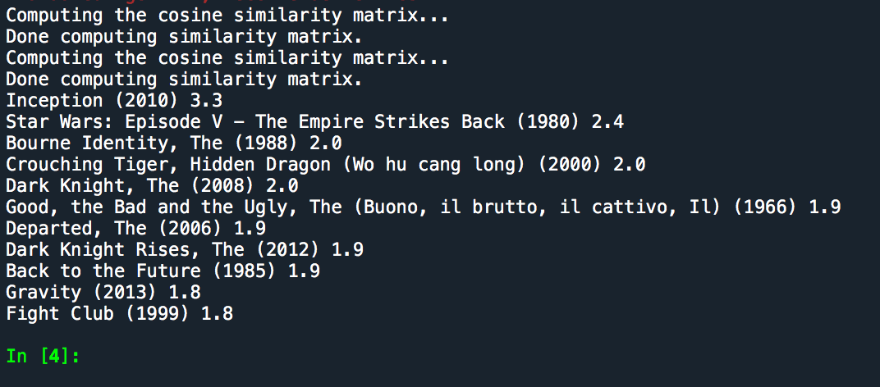

**Item-based Collaborative Filtering**:

This is similar to user-based, but just by flipping the focus here on to items. Recommending similar items based on what items I liked in the past. This might be better than user as the item remains same in its nature, as a math book remains a math book but not the same with user, as user might change his/her choices. Now, computation seems to be not that complicated as the matrix become much smaller.

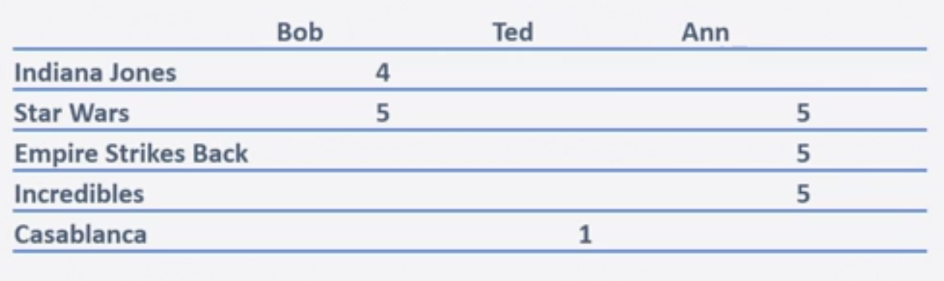 Computing the item similarity matrix, we see:

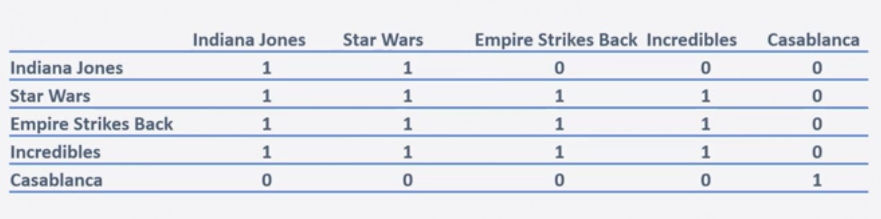

Now it appears that Bob has new set of suggestions better than user based collaborative filtering.

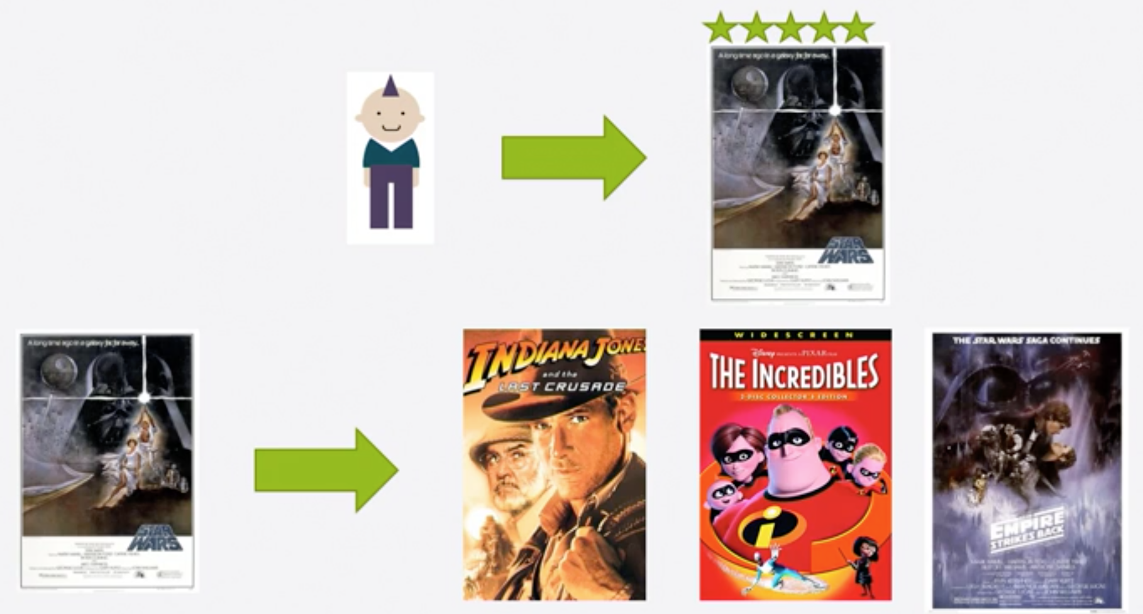

Now applying these to the *MovieLens* dataset for User 85.

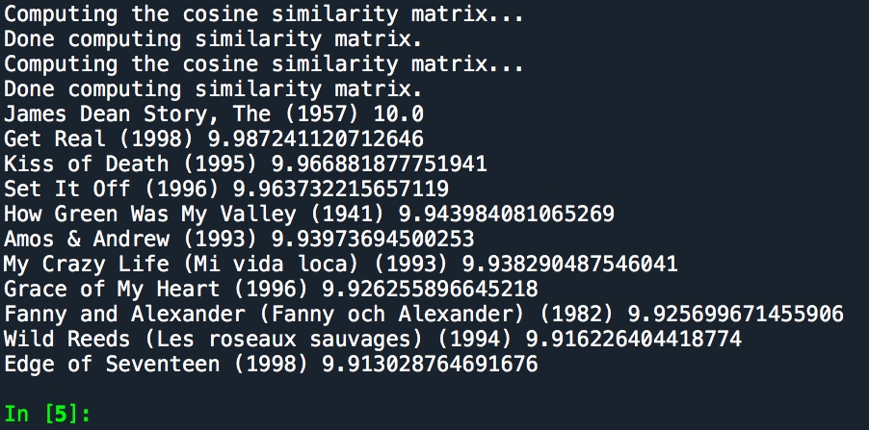

**Evaluating Collaborative Filtering**:

Although we can't make an accuracy check with user and item based collaborative filtering as they don’t make predictions, we can check the hit rate.

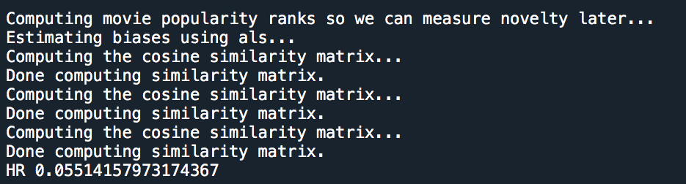

A hit rate of 5.5% is still good.

**References**:

1. Practical Recommender Systems Book – Kim Falk

<https://www.manning.com/books/practical-recommender-systems>

1. Sun-dog Education: Recommender Systems

<https://sundog-education.com/RecSys/>